2023

Planning & Management

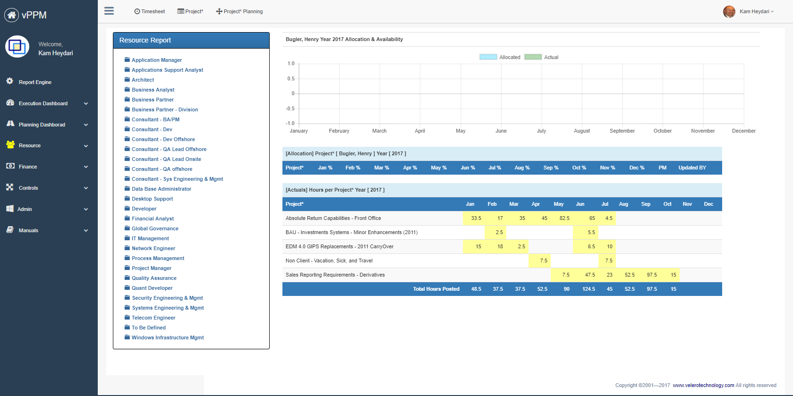

**Student Name:**

Animesh Shukla

**Assignment Name:**

Smart Package Delivery System

Contents

2. Background 2

2.1. Company Background 2

2.2. SWOT Analysis 2

2.3. Strategy Scorecard 3

2.4. Reference information 4

3. Project Definition 4

3.1. Problem 4

3.2. Action 4

3.3. Result/ Primary Project Objectives 5

3.4. Key Stakeholders 5

3.5. Project Deliverables/Outcomes/Success Criteria 6

3.6. Project Interdependencies and Inputs 6

3.7. Strategy Matrix 7

3.8. Project Conditions 7

3.8.1. Assumptions 7

3.8.2. Project ConstrainTs 8

3.8.3. Risks and Issues 9

3.9. Scope 9

3.9.1. In scope 9

3.9.2. Out of Scope 10

3.10. Work Breakdown Structure 11

3.11. Resource and Cost Estimate 11

3.11.1. Cost 11

3.11.2. Resource Requirements 12

3.12. Roles & Responsibility Matrix 13

3.13. Project Structure 14

3.14. Resource requirement Matrix 15

3.15. Project Schedule 16

# Background

In this section, your will be researching a company understanding its business and strategy to select an initiative that is aligned with the company’s goals.

## Company Background

**Company Name:**

Amazon is an American multinational technology company founded by Jeff Bezos in 1994. Initially an online bookstore, it has since expanded to offer a wide range of products and services, including e-commerce, streaming media, cloud computing, and artificial intelligence. Amazon is the world's largest online retailer, as well as one of the largest providers of cloud infrastructure services. The company's mission is to be the most customer-centric company on Earth, and it has achieved this by prioritizing innovation, speed, and customer satisfaction. As of 2021, Amazon has more than 1.3 million employees and operates in over 20 countries worldwide.

## SWOT Analysis

Using the format below identify company’s strengths, weaknesses, opportunities, and treats

|  |  |
| --- | --- |
| Strength   * One of the most recognized brands in the world * Massive customer base, with millions of active users worldwide * Advance logistics and delivery capabilities * Has one of the best employees with good skills | Weakness   * Struggle with counterfeit products and fake reviews on its platform * Heavy dependency on 3rd party sellers * Criticism for its labor practices * Company has limited physical stores * Net revenue is growing but making profit is becoming tougher |
| Opportunity   * International expansion * Advertising business growing rapidly, which presents an opportunity to further monetize its vast customer base * Exploring the healthcare space * Long distance gifting opportunities | Threats   * Other competitors like Alibaba, eBay, Facebook Marketplace * Regulatory challenges from governments and regulatory bodies * Prime target for cyberattacks * Natural disaster affects delivery capabilities |

## Strategy Scorecard

## Reference information

<https://sell.amazon.com/programs/amazon-global-logistics>

# Project Definition

Project Name: Smart Package Delivery System

## Problem

* + Company has been facing problems with customer getting their packages delivered late or not on their expected date
  + The company is also facing the issue of loss of package

## Action

* + Develop a critical feature which allows the customers to select a date of delivery and supplier company
  + If the package is available to be delivered on that date, the customer can also choose the delivery company based on the change in overall price of the package, delivery charge, as well as which delivery company is able to deliver the package on the chosen date
  + If no options are available according to customer, a dedicated chat and call support with a person to get the best solution
  + Regular update of package on SMS and emails pre and post delivery

## Result/ Primary Project Objectives

* + Reduce stress on delivery services for better inventory and logistics.
  + Due to regular updates of package delivery, loss of package would be minimized.

## Key Stakeholders

|  |  |  |
| --- | --- | --- |
| Name(title) | Department | Roles |
| CEO, CFO | Executive | Decision makers |
| Supply chain head | Executive | Decision makers |
| Logistics Head | Executive | Decision makers |

## Project Deliverables/Outcomes/Success Criteria

* Developing an onboarding quick document for easy navigation
* Incorporating a dedicated chat and call support feature on the product page
* Add multiple dates available for delivery
* Offer multiple suppliers list with comparative overall and delivery charge in product page
* Expand supply chain and logistics to support multiple date delivery feature

## Project Interdependencies and Inputs

|  |
| --- |
| Project Interdependencies and Inputs |
| * Dependencies on supply chain and logistics department to support flexible date delivery * Dependencies on factors like budget, promotional strategy, target audience behavior to determine success ratio * Dependencies on dedicated chat and call project to gather issues & provide better solutions |

## Strategy Matrix

|  |  |  |  |  |
| --- | --- | --- | --- | --- |
| Project Objectives | Strategies | | | |
| **Increase Revenue and Profit** | **Customer Satisfaction and Retention** | **Improve logistics and supply chain** | **Pre and post delivery services** |
| Flexible package delivery date and price | Yes | Yes | No | No |
| Better inventory and logistics | Yes | Yes | Yes | Yes |
| Quick customer support | No | Yes | No | Yes |
| Regular updates of package | No | Yes | No | Yes |

## Project Conditions

### Assumptions

| **ID** | **Item** |
| --- | --- |
| A1 | The project will operate for 6 months of timeline within a specific scope |
| A2 | All the teams involved in this project are well qualified to execute their tasks |
| A3 | Supply chain and logistics departments are successfully able to overcome the changes throughout the project |
| A4 | Necessary tools and resources are available to the teams to work on the project |

### Project ConstrainTs

| **ID** | **Item** |
| --- | --- |
| C1 | The team might face issues while implementing the availability of suppliers on multiple dates |
| C2 | There could be time constraints to meet deadlines that might be affected due to testing of all the features |
| C3 | Smooth collaboration with cellular companies is required for regular package updates which has left the inventory |

### Risks and Issues

|  |  |  |  |
| --- | --- | --- | --- |
| **Risk** | **Prob** | **Impact** | **Mitigation** |
| The suppliers may not cooperate with multiple dates of delivery | More likely to occur | Major | Direct communication with all the supplier teams to work towards flexible delivery and provide best solutions |
| Legal issues might arise to implement flexible delivery dates facility | More likely to occur | Moderate | Collaborating with legal experts is the best way to solve the compliance issues |
| Before project execution, instant availability of chat and call support executive is tough to setup | More likely to occur | Major | Having all the resources whether its system or support executive at Amazon is a way to mitigate the less or no availability issue |

## Scope

### In scope

| **ID** | **Type** | **Definition** |
| --- | --- | --- |
| IS1 | Browser compatibility | Platform is compatible with mobile and desktop version of browsers such as Chrome, Firefox, Safari, and Microsoft Edge |
| IS2 | Updated supplier information | Create and manage a process for regularly updating the supplier information and availability for delivery service |
| IS3 | Testing | Testing and quality assurance to guarantee that all new features perform properly and do not interfere with current functionality. |
| IS4 | Technology | Create ML algorithms to implement suppliers and the overall charges comparison data on while selecting dates |

### Out of Scope

| **ID** | **Item** |
| --- | --- |
| OS1 | Collaboration between cellular companies for frequent package upgrades |
| OS2 | Creation of new products or services not related to the current project scope |
| OS3 | Marketing or advertising initiatives that are more extensive than what is required to advertise the new features on the product page |

## Work Breakdown Structure

## Resource and Cost Estimate

### Cost

|  |  |  |
| --- | --- | --- |
| Cost Description | Amount | Note |
| Software | $45,000 | Database management software, OS, Jira, Tableau, Dialogflow (chatbot), project management software, documentation software, backup and recovery software, ML based software |
| Hardware | $40,000 | Desktops, Laptops, Servers, and other devices |
| Other Costs | $30,000 | Miscellaneous expenses |
| Contingency | $11,500 | Includes a reserve budget to cover unforeseen expenses that may arise during the project's execution. |
| Total | $126,500 |  |

### Resource Requirements

Please identify the required skills needed by your project using the available resources in the Velero product.

|  |  |
| --- | --- |
| Resource Type | Note |
| Sponsor | Assumes responsibility and duty for the success of a project by providing the appropriate resources, support, and direction |
| Stakeholders | Overall project management, comprising planning, scheduling, budgeting, risk management, stakeholder communication, and ensuring project completion within stipulated timelines |
| Project Manager | Responsible for planning, executing, and delivering the project on time, within budget, and to the required quality standards |
| Business Analyst | Determine the project's business goals, requirements, and restrictions, then evaluate data, perform market research, and collect user input to build functional specifications |
| Software Developer | In charge of building software programs and adding new features. Notes might include programming languages and frameworks, software development expertise, and understanding of software development tools. |
| Quality Assurance Engineer | In charge of testing and guaranteeing the quality of software and hardware. Experience in software and hardware testing, understanding of testing tools and procedures, and attention to detail are all possible qualifications |
| DBA | Responsible for ensuring that the database systems are secure, reliable, and efficient |
| UI/UX Designer | Would collaborate closely with the developer to ensure that the design is consistent with the functional specifications |

## Roles & Responsibility Matrix

|  |  |  |  |  |  |  |  |  |
| --- | --- | --- | --- | --- | --- | --- | --- | --- |
| **Project Activity** | **Roles** | | | | | | | |
| **Sponsor** | **Stakeholder** | **PM** | **BA** | **Software**  **Developer** | **QA** | **DBA** | **UI/UX** |
| Budgeting | I |  | R/A |  |  |  |  |  |
| Requirements |  |  | C | R/A | C |  |  |  |
| System Design |  |  | R |  |  |  |  |  |
| Architecture |  |  | R |  |  |  |  |  |
| App Design |  |  |  |  |  |  |  | R/A |
| Project Planning |  | I | A | R |  |  |  |  |
| Project Comm |  | I | R | A |  |  |  |  |
| Training |  |  | R |  |  |  |  |  |
| DB Management |  |  |  |  |  |  | R/A |  |
| Testing |  |  |  |  |  | R/A |  |  |
| Documentation |  |  | C | C |  |  |  |  |
| Sign-off | I | A | R | A | C | C | C | C |

|  |  |
| --- | --- |
| **Responsible** | People or stakeholders who are the "doers" of the work. They must complete the task or objective or make the decision. Several people can be jointly *Responsible*. |
| **Accountable** | Person or stakeholder who is the "owner" of the work. He or she must sign off or approve when the task, objective, or decision is complete. This person must make sure that responsibilities are assigned in the matrix for all related activities. ***Success requires that there is only one person Accountable.*** |
| **Consulted** | People or stakeholders who need to give input before the work can be done and signed off on. These people are "in the loop" and active participants. |
| **Informed** | People or stakeholders who need to be kept "in the picture." They need updates on progress or decisions, but do not need to be formally consulted, nor do they contribute directly to the task or decision. |

## Project Structure

## Resource requirement Matrix

|  |  |  |  |  |  |  |
| --- | --- | --- | --- | --- | --- | --- |
| Resource/Month | 1 | 2 | 3 | 4 | 5 | 6 |
| Project Manager | 1 | 1 | 1 | 1 | 1 | 1 |
| Business Analyst | 1 | 1 | 1 | 1 | 1 | 1 |
| UI/UX Designer |  | 1 | 1 | 1 | 1 | 1 |
| Software Developer |  | 1 | 1 | 2 | 2 | 2 |
| QA |  |  |  | 1 | 1 | 1 |
| DBA |  | 1 | 1 | 1 | 1 | 1 |

## Project Schedule

